LEARNING TOPICS

- Web Stack
- Varnish Cache
- Concurrent User
- Pricing & Naming Conventions
- Single & Multi-tier
- Latency
- Apache
- Thunderstack
- Hyperviser Learning

1) Web Stack:
A Web stack is the collection of software required for Web development. At a minimum, a Web stack contains an operating system (OS), a programming language, database software and a Web server. ... A Web stack is one type of solution stack -- an ordered collection of software that performs a particular task.

Web Stack In CloudWays:

NginX:

Cloudways Platform comes with a web server called Nginx as a part of our default web stack. All of our cloud servers are equipped with robust Nginx to serve static content requests. It helps to serve more audiences rapidly while lowering down the load on your server as it needs minimal resources. The currently available version of Nginx is 1.21.x, and the available ports are 80 and 443.

To check the version of nginX, here is the commad:

dpkg -l | grep nginx

Varnish Cache:
Cloudways Platform offers built-in Varnish Cache as a part of our optimization stack. It is an open-source HTTP accelerator designed for dynamic websites to cache and deliver static and dynamic content requests. The currently available version of Varnish is 6.0.x. It works excellent with Nginx and Apache to provide a superior experience to your site visitors.

To check the version of Varnish Cache, here is the command:

dpkg -l | grep varnish

Apache:
Apache is a renowned HTTP web server and is developed and maintained by Apache Foundation. Cloudways Platform also includes a blazing-fast Apache web server as a part of our lightning-fast and optimized web stack. Apache is well known for its reliability, compatibility, and impressive range of features. The installed version is Apache 2.4.x for Debian 10 servers.

dpkg -l | grep apache

Modules Of Apache

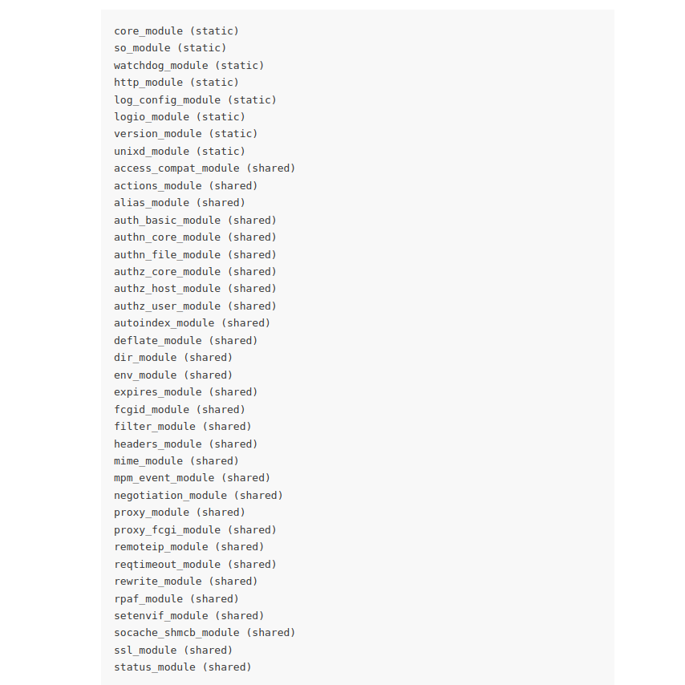

Database:

Cloudways currently has MySQL v5.5, MySQL v5.6, MySQL v5.7, MariaDB v10.0, MariaDB v10.1, MariaDB v10.2, MariaDB v10.3 versions supported. However, newer servers and servers deployed after September 11th, 2019 are available with Debian 9 distribution and MariaDB v10.1 as a default database. You always have the ability to upgrade the database version to MariaDB v10.2 or MariaDB v10.3 as per your requirements.

The latest versions of MariaDB also include GIS and JSON features. MySQL and MariaDB are critical fragments of almost all PHP applications, such as Magento, WordPress, etc.

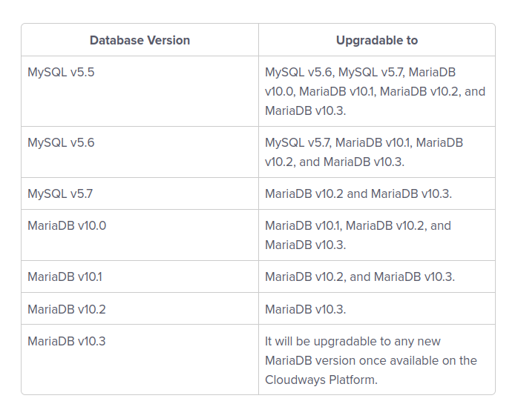

MariaDB is a drop-in replacement of MySQL, which means that MySQL users can move to MariaDB without having compatibility issues. As we know that MySQL core components are tables, roles, constraints, stored procedures, and views.

Since MariaDB is a fork of MySQL thus, the indexes, database structures, command-line tools, and syntax of the queries of MariaDB are the same as MySQL which results in no alteration to be done at the application level to use the MariaDB which also means that data and table definition files are fully compatible. Also, MySQL connectors will work with MariaDB without any alteration, and the client protocols, APIs, and structures remain the same too with MariaDB.

MySQL community version works on one thread per connection, which means that multiple connections are not supported on a single thread; therefore, in MySQL number of connections is directly proportional to the number of threads, which leads to slow query results and average performance. On the other hand, MariaDB offers a thread pooling facility where a pool will have open threads in which a new connection can pick up and query the database, so MariaDB does not open a new thread for a new connection, which results in faster query results and better performance.

MariaDB also offers a groundbreaking feature of Storage Engines, which are pre-installed, such as InnoDB, CSV, and Aria, etc. whereas MySQL does not provide the Storage Engines, but it can be installed afterward manually. A storage engine is used to create, read, update data from a database by the Database Management System (DBMS).

Memcached:
Memcached is a caching system used to speed up dynamic web applications by storing data in the server’s memory for a limited time to ease the load on the database. The installed version of Memcached is 1.5.x.

dpkg -l | grep memcached

PHP:
Your new server is configured to use PHP 7.4 by default. You can upgrade or downgrade to a different version using the Cloudways Platform. Available versions of PHP include PHP 5.6, 7.0, 7.1, 7.2, 7.3, 7.4, and 8.0.

The latest version is PHP 8.0, which requires Debian 9 or Debian 10. It is not compatible with Debian 7 and Debian 8. You can also check your application compatibility with different available PHP versions.

Versions & Support:

PHP 5.6

Supported Applications

✓ WordPress 5.6.x
✓ Magento 1.9.x

Unsupported Applications

✕ Magento 2.x and higher
✕ Laravel 8.26.x

PHP 7.0

Supported Applications

✓ WordPress 4.3.x and higher
✓ Magento 1.9.x
✓ Laravel 5.2 ~ 5.5

Unsupported Applications

✕ Magento 2.x and higher
✕ Laravel 5.6 and higher

PHP 7.1

Supported Applications

✓ WordPress 4.3 and higher
✓ Magento 1.9.x
✓ Laravel 5.2 ~ 5.8

Unsupported Applications

✕ Magento 2.3.6 and higher
✕ Laravel 6.x and higher

PHP 7.2

Supported Applications

✓ WordPress 4.3 and higher
✓ Magento 1.9.x ~ 2.3.6
✓ Laravel 6.x and higher

Unsupported Applications

✕ Magento 2.4.1 and higher
✕ Laravel 5.2 ~ 5.8

PHP 7.3

Supported Applications

✓ WordPress 4.3 and higher
✓ Magento 2.x ~ 2.3.6
✓ Laravel 6.x and higher

Unsupported Applications

✕ Magento 1.9.x and 2.4.1
✕ Laravel 5.2 ~ 5.8

PHP 7.4

Supported Applications

✓ WordPress 4.3.x and higher
✓ Magento 2.4.1
✓ Laravel 6.x and higher

Unsupported Applications

✕ Magento 1.9.x ~ 2.3.6
✕ Laravel 5.2 ~ 5.8

PHP 8.0

Supported Applications

✓ WordPress 5.6.x and higher
✓ Laravel 6.20.x and higher

Unsupported Applications

✕ Magento 1.9.x and higher
✕ Laravel 5.2 ~ 5.8

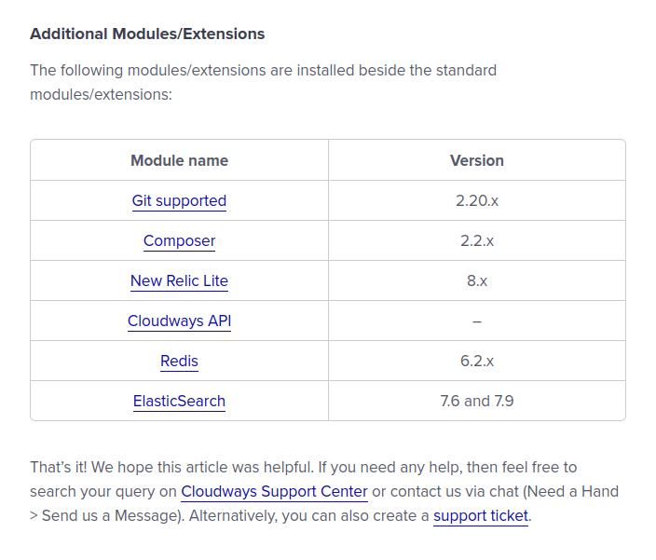

2) Concurrent User:

Pricing & Naming Conventions:

LOGGING IN AND SETTING SERVER

In server management, there are multiple options to go through.

- Setting Credentials:

Set Username and password for the server. These are SFTP and SSH access details for all applications on the server.

- Monitoring:

It includes the server utilization statistics so that o that you have a quick and easy way of monitoring your server’s resources.
Three tabs are there, Summary, Details, and New Relic.

In the Summary tab, we have RAM usage, CPU usage. Disk Usage, and Bandwidth Usage. In addition we can also track the details application-wise. Its CPU usage %, plus disk and memory usage.

In the Details Tab, we have multiple options to select and view the line graph of the resource usage. Here are the elements that we can analyze:

- Idle CPU - Percentage of FREE (not used) CPU. Higher means server is less busy. If it is consistently below 10 to 20%, consider increasing your server size.

- Free Disk Space - Free space in GB in disk holding data. Increase size if lower than 2GB.

- Reads Per Second - Read operations to your disk per second. Higher means busier disk. If consistently above 1000, your Application's performance will suffer. Contact Live Chat Support.

- Writes Per Second - Write operations to your disk per second. Higher means busier disk. If consistently above 1000, your Application's performance will suffer. Contact Live Chat Support.

- Free Memory - Free (unused) memory in MB for your server. Higher is better. If consistently below 100MB, your application will start crashing, consider increasing server size.

- Incoming Network Traffic - Incoming network traffic in Mbps (Megabits per second). The higher, the busier your application is.
- Outgoing Network Traffic - Outgoing network traffic in Mbps (Megabits per second). The higher the busier your application.

- APC Fill Ratio - Percentage of used Alternate PHP Cache space. APC is one of several caching layers used by Cloudways to speed up your site. If it's consistently close to 100%, it needs to be increased. Contact Live Chat support.

- APC Hit Rate - Number of successful hits to the Alternate PHP Cache space. APC is one of several caching layers used by Cloudways to speed up your site. Higher is better. It should be above 90%.

- Monthly Bandwidth - On-going bandwidth (in GB) used each month. Counter is reset at the start of each month.

- Memcached Filled Ratio - Percentage of used Memcached Cache space. Memcached is one of several caching layers used by Cloudways to speed up your site. If it's consistently above 90%, it needs to be increased. Contact support.

- Varnish Hit Rate - Number of successful hits to Varnish Cache. Varnish is one of several caching layers used by Cloudways to speed up your site. Higher is better. It should be above 80%.

- Varnish Nuked - Number of items that have had to be kicked out of the Varnish Cache due to lack of space. Varnish is one of several caching layers used by Cloudways to speed up your site. Lower is better. If it's consistently above 0 (Zero), Varnish cache must be increased. Contact Live Chat support.

- Auto-healing Restarts - Auto-healing restarts happen when a service has been killed due to low memory. Our Monitoring system tries to automatically restart it. Frequent restarts mean your server needs resources and you need to consider upgrading to server size. Recurrent service restarts will deteriorate your visitors' experience.

- MySQL Connections - Number of connections established to the MySQL database. If it is consistently above 125, consider increasing MySQL Max Connections Limit.

For all of the above monttoring options, we can set the time stamp like 1 Hour, 12 Hours, 1 Day, 7 Days, 1 month. And 6 months.

Additionally, there is an option of New Relic which offers built-in App Monitoring tool that can help debug problems within your application and monitor its activity closely.

- Manage Services:

In this tab, we have all the services and we can Allow Run, Restart, Stop, Enable, and Disable the services. The services include, Apache, Memcached, MySQL, NginX, New Relic, PHP FPM, and Varnish Cache.

- Setting Packages:
Here we can manage server level settings and packages.
- Security:
- Vertical Scaling:
- Backups:
- SMTP:

Single Tier & Multi Tier:

All resources are at the same server in Single Tier. It is good for new startups.

Multi Tier have multiple servers. Latency is lowered down in Multi-tier.

Failover in multi-tier is good enough
Multi-tier is

Latency depends on routers in between a network.

Priority setting through QoS.

